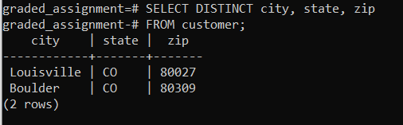

SELECT DISTINCT city, state, zip

FROM customer;